Department of Computer Science and Technology

Subject Name: Principles of Operating Systems Subject Code: CSH 211

Topic: Memory Management

Tutorial: 9

Aim: To gain familiarity with Memory Management

Section-A

1. Which one of the following is the address generated by CPU?
a) Physical address b) absolute address c) logical address d) none of the mentioned

2. Run time mapping from virtual to physical address is done by
a) Memory management unit b) CPU c) PCI d) none of the mentioned

3. Memory management technique in which system stores and retrieves data from secondary storage for use in main memory is called
a) Fragmentation b) paging c) mapping d) none of the mentioned

4. The address of a page table in memory is pointed by
a) Stack pointer b) page table base register
c) Page register d) program counter

5. Program always deals with
a) Logical address b) absolute address c) physical address d) relative address

6. The page table contains
a) Base address of each page in physical memory b) page offset
c) Page size d) none of the mentioned

7. What is compaction?
a) a technique for overcoming internal fragmentation
b) a paging technique
c) a technique for overcoming external fragmentation
d) a technique for overcoming fatal error

8. Operating System maintains the page table for
a) Each process b) each thread c) each instruction d) each address

9. Paging suffers from internal fragmentation and Segmentation suffers from external fragmentation

Section-B

Q1. A process is to be swapped in at the location 20100 in memory. If logical addresses generated by the process are 200, 345, 440, and 550, what are the corresponding physical addresses?
Solution
The relocation register will be loaded with the address 20100. So adding the logical addresses
to the relocation register, the corresponding physical addresses are as follows:
20100 + 200 = 20300
20100 + 345 = 20445
20100 + 440 = 20540
20100 + 550 = 20650

Q2. A process has relocatable code of size of 900 K. The relocation register is loaded with 40020 K and the limit register contains the address 41000 K. if the processor generates a logical address 990, where will it be located in the physical memory?
Solution
The physical address corresponding to logical address 990
= relocation register address + logical address
= 40020 + 990 = 41010
But the process will not be allocated, because it is greater than the address in the limit register,
hence, violating the criterion for protection. Consequently, an interrupt will be generated.

Q3. Three processes P1, P2 and P3 of size 21900, 21950, and 21990 bytes, respectively, need space in the memory. If equal sized partitions of 22000 bytes are allocated to P1, P2 and P3, will there be any fragmentation in this allocation?
Solution
After allocating the partitions to the processes, the leftover space in each partition is estimated
by the difference between partition size and process size. Hence,
The leftover space in the first partition = 22000 – 21900 = 100 bytes
The leftover space in the second partition = 22000 – 21950 = 50 bytes
The leftover space in the third partition = 22000 – 21990 = 10 bytes.

Q4. Differentiate between
a) External and Internal fragmentation.
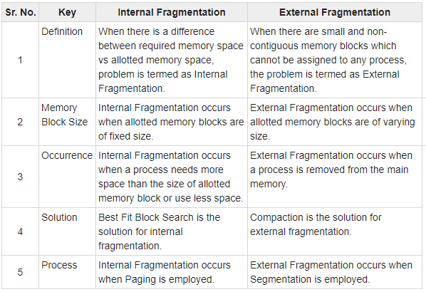
b) Virtual (logical) address and a physical address
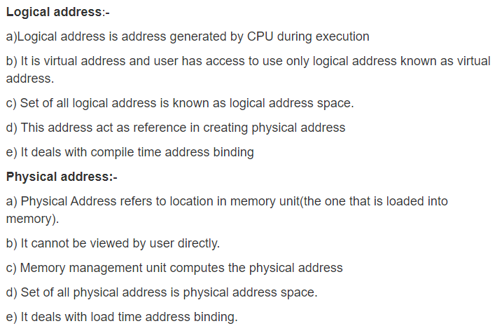

Q5. A program’s logical memory has been divided into five pages and these pages are allocated frames, 2,6,3,7, and 5. Show the mapping of logical memory to physical memory.
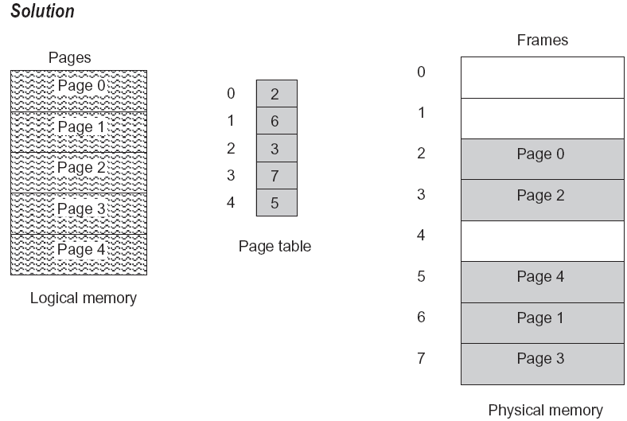
Q6. In a paging scheme, 16-bit addresses are used with a page size of 512 bytes. If the logical address is 0000010001111101, how many bits are used for the page number and offset? Compute the page number and offset as well.
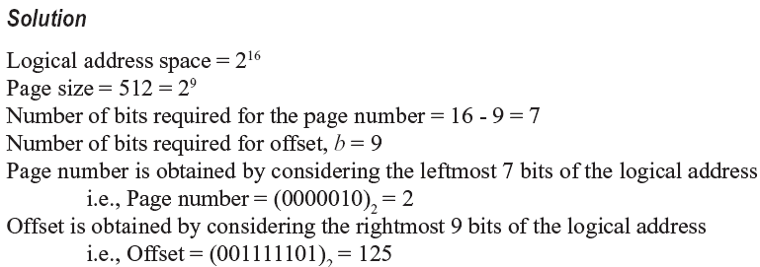

Q7. There are 128 pages in a logical address space, with a page size of 1024 bytes. How many bits will be there in the logical address?
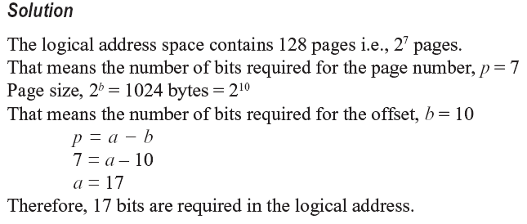

Q.8 There is a system with 64 pages of 512 bytes page size and a physical memory of 32 frames .How many bits are required in the logical and physical address?
Solution
Given, page size = 512 bytes = 2⁹ i.e., b = 9
No. of pages = 64 = 2⁶ i.e., p = 6
Since p = a – b, a = 15
Therefore, 15 bits are required in the logical address.
Since the number of bits required for offset, b = 9 and
The number of bits required to address 32 (2⁵) frames = 5
Therefore, after appending the number of bits required for the frame size to the offset, 14 bits
are required in the physical address.

Q.9 Consider a logical address space of 8 pages of 1024 words each mapped onto a physical memory of 32 frames.
a. How many bits are there in the logical address?
b. How many bits are there in the physical address?

